

|  |
| --- |
| **MATHEMATICS DEPARTMENT**  **Year 11 Specialist – 2016**  **Test Number 4:**  **Combinations and Circle Geometry**  **Resource Rich** |

Total Mark

/47

**Name: _______________________________________ Teacher: DDA**

**Marks: 47**

**Time Allowed: 45 minutes**

**Weight: 5%**

**Instructions:** You permitted 1 A4 page of notes and your calculators. Show your working where appropriate remembering you must show working for questions worth more than 2 marks.

_________________________________________________________________________

Part A

5 multiple choice questions

5 marks

**1**  Counting the 1 at the top as row 0, what is the fifth number on row 9 of Pascal’s triangle?

**A**  126

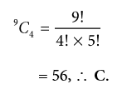**B**    70

**C**   56

**D**  120

**E**  210

[1 mark]

**2**  In the diagram, O is the centre of the circle. The value of ∠ACB is:

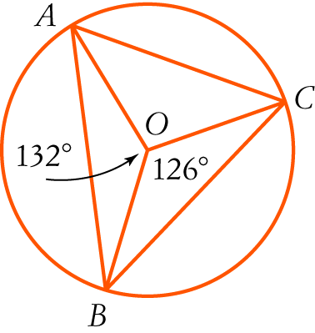

ACB = 66°, (angle at the centre is twice angle at circumference standing on arc AB,∴ C.

**A**  24°

**B**   27°

**C**  66°

**D**  63°

**E**  39°

[1 mark]

**3** The size of ∠VTU in the diagram is:

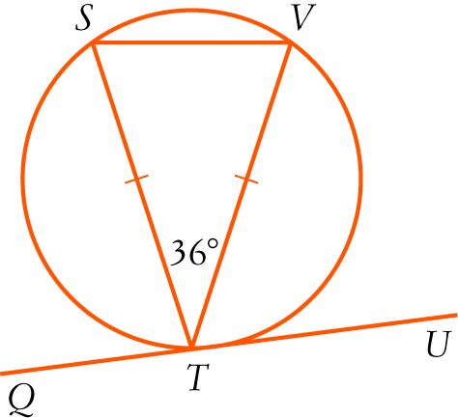

VST = 72° (base angles equal, angle sum of isosceles ∆ VST), ∠VTU = 72° (angle between the   
chord and the tangent equals the angle in the alternate segment), ∴ A.

**A**   72°

**B**     54°

**C**    36°

**D**  18°

**E**    90°

[1 mark]

**4**  The value of x in the diagram is:

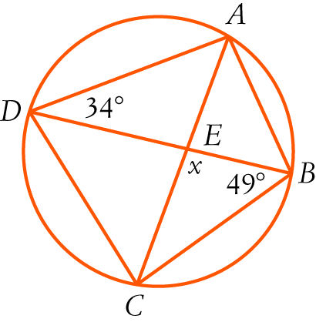

∠ACB = 34° (angles standing on arc AB) x = 97 (angle sum of triangle), ∴ E.

**A**  83°

**B**  68°

**C**  98°

**D**  96°

**E**    97°

[1 mark]

**5** 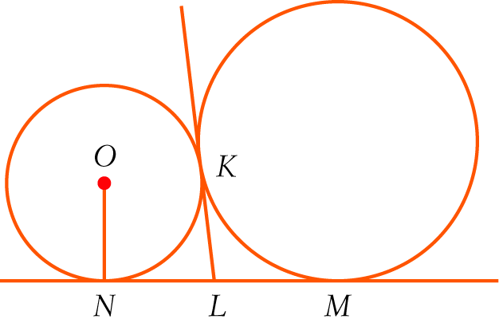

In the diagram, NM is a common tangent to the circles. KL is also a common tangent and O is the centre of the smaller circle.

Consider the statements:

I LN = NO II KL = LN III LN = LM

Which of the statements are true?

**A**  I and II

**B**  I, II and III

∠ Tangents drawn from a common external point are equal, so KL = LN and KL = LM, so LN = LM, ∴ C.

**C** II and III

**D**  I and III

**E**  None of the above.

[1 mark]

Part B

8 short answer questions

32 marks

Show your working where appropriate.

**6**  nC6 = 7 × nC4. Solve for n.



[5 mark]

**7**  There is only one black jelly bean in a packet with 20 left in it.

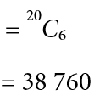**a**  How many different selections of 6 jelly beans are possible?

**b**  How many selections include the black one?

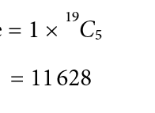

[4 marks]

**8**  A class has 24 students. Of these students, 9 do not do any of Physics, Chemistry or Computer Science. There are 6 who do Physics and Chemistry, 4 who do Physics and Computer Science and 5 who do Chemistry and Computer Science. There are 11 Computer Science students, 8 who do Physics and 8 who do Chemistry. Use the inclusion-exclusion principle to find how many do all three of Physics, Chemistry and Computer Science?

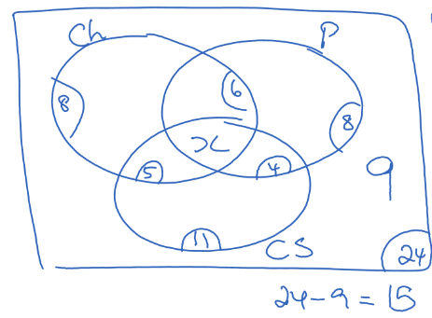

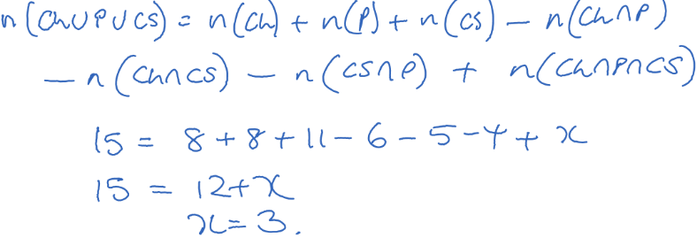



[5 marks]

**9** What is the probability of getting exactly 2 faulty switches if you take 5 switches from a box of   
12 switches with 4 faulty ones in it?

Number ways of getting 2 faulty switches and 3 good switches = 4C2 × 8C3 = 336

Number ways of getting 5 switches = 12C5 = 792

P(2 faulty switches) =  = 0.

[3 marks]

**10** In the diagram, DF = 6 cm and OE = 4 cm.

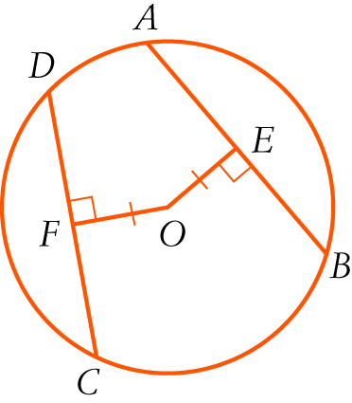

**a**  Find the length of AB giving reasons.

AB = 12 [1 mark]

(DC = AB, chords equidistant from centre of circle are equal in length), [1 mark]  
 (DC = 2 DF, line through centre of circle perpendicular to chord bisects chord) [1 mark]

**b**  Find the radius of the circle in exact form.

OD 2 = OF 2 + DF 2 r 2 = 62 + 42 [1 mark]

****cm [1 mark]

[5 marks]

**11** Find the value of x in surd form, giving reasons.

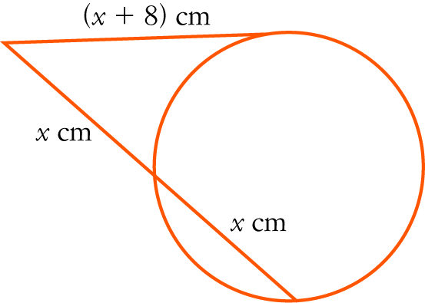

(x + 8)2 = x(x + x) (the square on the tangent equals the product of the intercepts of the   
intersecting secant) [1 mark]

x2 + 16x + 64 = 2x2

x2 − 16x − 64 = 0 [1 mark]

x=8 [1 mark]

x>0 so x=8 [1 mark]

[4 marks]

**12** In the diagram, AB is a diameter of the larger circle with centre C and A is the centre of the smaller circle.   
The circles intersect at D. Explain why BD is a tangent to the smaller circle.

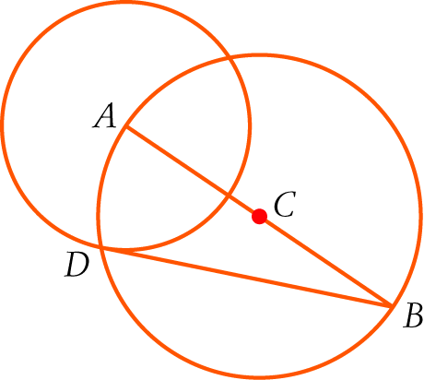

ADB = 90° (angle in a semicircle.) [1 mark] 

∴ AD BD but AD is a radius of the smaller circle. [1 mark]

∴ BD is a tangent (tangent meets radius at right angles) [1 mark]

[3 marks]

**13** Find the value of x, giving reasons.

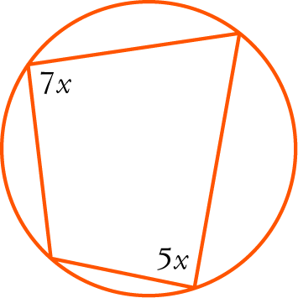

7x + 5x = 180 [1 mark] (opposite angles in cyclic quadrilateral are supplementary.)[1 mark]  
∴ x = 15 [1 mark]

[3 marks]

Part C

2 analysis questions, 10 marks. Show your working where appropriate.

**14** The ninth number of a row of Pascal’s triangle is half of the eighth number in the row. What is next (tenth) number in the row?

Ninth number in row n = nC8 =  [1 mark]

Eighth number in row n = nC7 =  [1 mark]

Thus  [1 mark]

So 

So n = 11 [1 mark]

The tenth number in the row is 11C9 = 55 [1 mark]

[5 marks]

**15** In the diagram, TR = TS. Prove that PQ = PR.

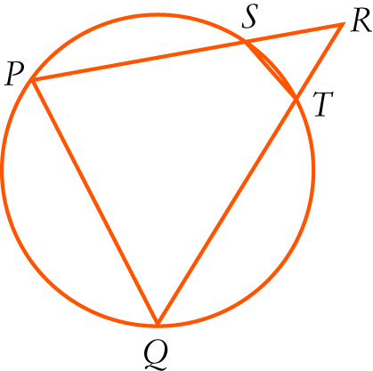

TSR =TRS (base angles of isosceles triangle) [1 mark]  
Now ∠PQR = ∠TSR [1 mark] (exterior angle of cyclic quadrilateral = interior opposite angle)[1 mark]  
∠PQR = ∠TRS (both = ∠TSR) [1 mark]  
PQ = PR (sides opposite equal angles in triangle are equal) [1 mark]

Alternate Proof:

In

(AA) [2 marks]

[1 mark]

**[2 marks]**

[5 marks]